A Data Science Approach to Forecast Electricity Consumption in Australia

Alan Nguyen z5386192  
Janany Nishatharan z5390604  
Darryn Marjoram z5484676

Table of Contents

0.1Introduction and Motivation 1

0.2Brief Literature Review 1

0.3Methods, Software and Data Description 2

0.4Activities and Schedule 3

References 5

## 0.1 Introduction and Motivation

The integration of rooftop energy Australia electricity grid has been growing strongly in Australia for more than 12 years contributing to 11.2% or 20MW of Australia’s electricity generation by 2023 (Clean Energy Council, 2024). This growing adoption presents unique challenges and opportunities in electricity demand forecasting, particularly as it relates to managing fluctuations throughout the year and across different weather conditions. Our research question “**How does the integration of solar panel adoption data influence our predictions for seasonal electricity demand?**” seeks to determine how incorporating data on rooftop solar energy can enhance the accuracy of electricity demand forecasts, both seasonally and daily.

We aim to explore how demand varies with changes in insolation and temperature based on seasonality. Additionally, we will investigate potential correlations between insolation and temperature to determine their material impact on demand forecasting. This analysis is crucial for effective grid and power allocation, facilitating more informed planning for when to ramp up generators and how to adapt infrastructure in regions impacted by sunlight or overcast conditions

## 0.2 Brief Literature Review

The study "Short-term Renewable Energy Consumption and Generation Forecasting: A Case Study of Western Australia" aligns with our research by exploring how rooftop solar energy data can enhance energy forecast accuracy. It focuses on optimising short-term energy consumption and generation models using advanced deep learning techniques like LSTM. By analysing high-resolution smart meter data, including rooftop PV generation, household consumption, and weather conditions, the study shows that integrating granular data improves forecast accuracy, directly addressing the variability of solar energy.

The study demonstrates that LSTM models outperform traditional forecasting methods in scenarios involving renewable energy. This supports our research by showing that accounting for rooftop Solar's dynamic nature leads to more accurate electricity demand forecasts. By highlighting the effectiveness of these models in managing energy flows and supporting P2P energy trading, the study underscores the value of using solar data to enhance grid stability and energy management, reinforcing our focus on improving seasonal or daily electricity demand forecasts.

The study "The Impact of Rooftop Solar on Wholesale Electricity Demand in the Australian National Electricity Market" by Guan Yana and Lin Han examines how increasing rooftop solar installations affect electricity demand within the NEM. The rise in rooftop solar capacity has changed power demand patterns, leading to significant shifts in grid consumption and market dynamics. Using half-hourly data from 2009 to 2019, the researchers estimate solar energy generation and employ regression models to forecast wholesale electricity demand. Their findings reveal that rooftop solar has reduced daytime grid consumption, creating a "duck curve" with low demand during sunny periods and high demand in the early evening. The study predicts decreased electricity demand across most states from 2019 to 2034.

This research highlights the importance of incorporating rooftop solar data into demand forecasts, showing how increased solar capacity influences electricity demand, especially during peak sunlight periods. Our report will be considered successful if it identifies a more accurate method for forecasting electricity demand by accounting for rooftop solar data.

## 0.3 Methods, Software and Data Description

**Seasonal Autoregressive Integrated Moving Average (SARIMA).** This characteristic is crucial when modeling the output of rooftop solar panels that vary across seasons.   
**Long Short-term Memory (LSTM) networks** Well-suited for capturing the dynamic demand patterns driven by rooftop solar generation, reflecting the time-dependent nature of solar energy output.  
**Random Forest** involves multiple decision trees to improve predictive accuracy and is adept at handling large, complex datasets.

**Software and Libraries**

Our group will code and model with R. This is a tool the team is most familiar with. We will adopt libraries to tackle the model, for example LTSM or Random Forest. Documentation and code will be stored in GitHub and Rmarkdown. The final report will be completed on Rmarkdown. Please refer to table 1 in the appendix for full breakdown.

**Data Description**

Total Electricity Demand Dataset (NSW): This dataset provides electricity consumption in New South Wales. It includes variables such as 'DATETIME','TotalDemand',"RegionID" with 196513 rows. The data is essential for developing forecasting models, as historical demand data is a key predictor of future electricity needs.

Air Temperature Dataset (NSW): This dataset includes air temperature reading from the Bankstown airport weather station in NSW. It contains 'DATETIME', 'TEMPERATURE' and 'LOCATION'. It has 220326 rows. This data helps explore the relationship between temperature and electricity demand, potentially improving forecast accuracy.

Forecasted Demand Dataset (NSW): This dataset provides half-hourly electricity demand forecasts for NSW. Variables are 'DATETIME', 'FORECASTDEMAND', 'REGIONID', 'PREDISPATCHSEQID', 'PERIODID' and 'LASTCHANGE' and 10906019 rows. This dataset is valuable for validating predictive models by comparing forecasted and actual demand, which helps refine forecasting accuracy.

## 0.4 Activities and Schedule

Our group has met multiple times since orientation week, starting with brief introductions and sharing our backgrounds. We meet at least twice a week: once with our lecturer and once among ourselves. Each meeting is structured with a prepared agenda, and we keep minutes for record-keeping. All team members are encouraged to add discussion points to the agendas. All documents are stored in MS Teams and GitHub.

Currently, we are using a Gantt chart to manage our workload and track timelines efficiently (refer to Chart 1 in the appendix). Tasks are divided based on the team members' strengths.

The team naturally assumed roles based on their skills and experience. Please refer to Chart 2 for the mind map of the team. Alan manages the project, ensuring the team is on track and assigning tasks such as setting up projects and supporting team members. Darryn, the research lead, excels at diving deeply into questions and raises interesting points for the team to consider. Janany, the data analyst, manages the methodology and provides best practices for data analysis.

**Appendix**

Table 1 – Tools used

|  |  |
| --- | --- |
| R | Statistical Analysis and modelling |
| R ‘forecast’ | Sarima modelling |
| R ‘keras’/’TensorFlow’ | LSTM modelling |
| R ‘caret’ | Random Forest |
| RMarkdown | For reporting on results |
| GitHub and MS Teams | Repository and communication |

**Chart 1 – Gantt Chart**

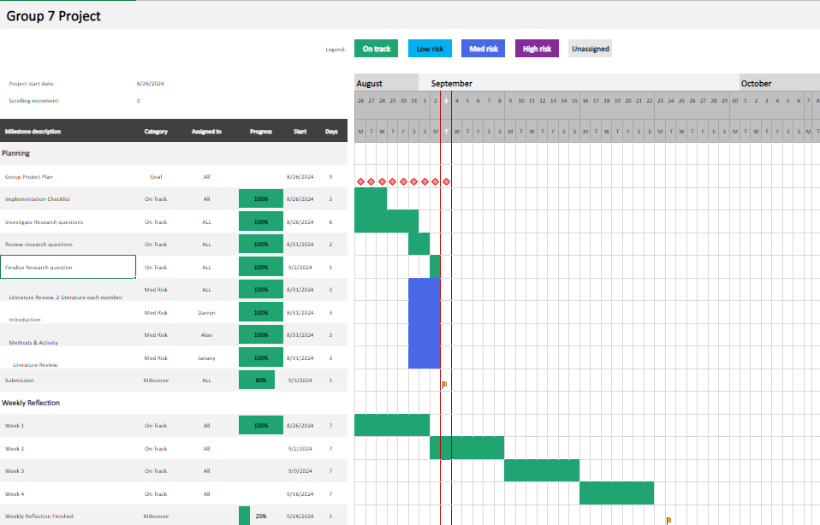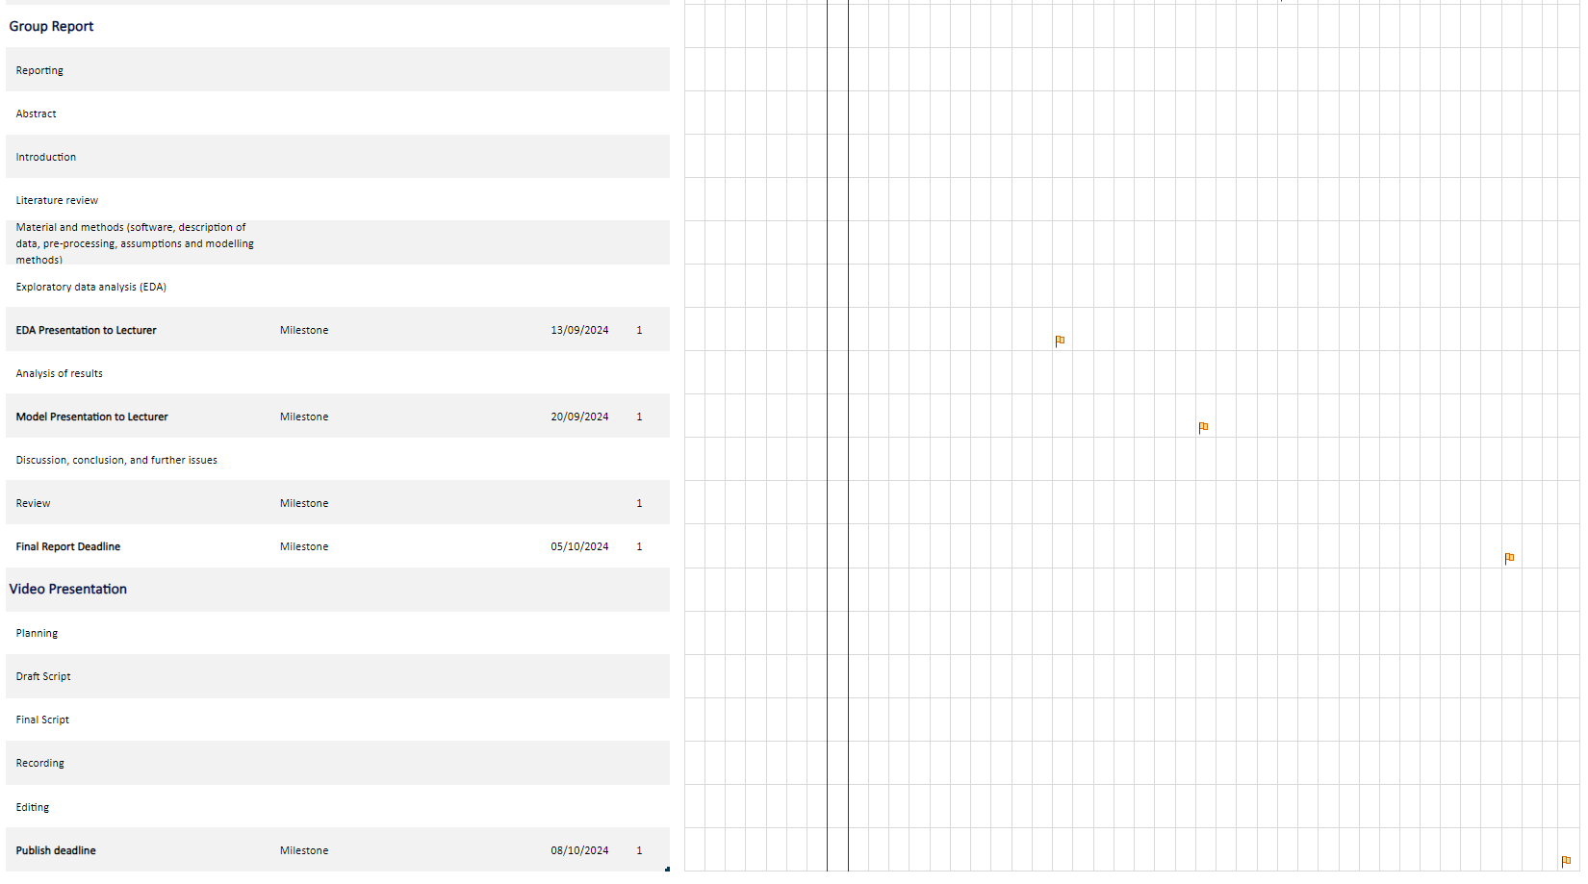

**Chart 2 – Mind map**

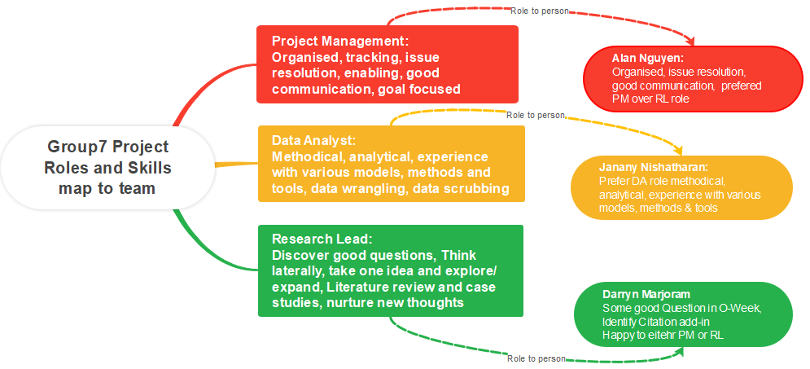

# References

* Clean Energy Council. (n.d.). Rooftop solar generates over 10 per cent of Australia’s electricity. Available at: <https://cleanenergycouncil.org.au/news-resources/rooftop-solar-generates-over-10-per-cent-of-australias-electricity>
* Razavi, R., Cheng, J., Woo, L., Wang, J. and Tapper, P. (2020). From Load to Net Energy Forecasting: Short-Term Residential Forecasting for the Blend of Load and PV Behind the Meter. *IEEE Transactions on Sustainable Energy*. Available at: <https://ieeexplore.ieee.org/document/9193901>
* Abu-Salih, A.M., Mostafa, S.A., Ahmad, M.O., Pathan, A.S.K. and Ramachandran, M. (2022). Short-term renewable energy consumption and generation forecasting: A case study of Western Australia. *Heliyon*. Available at: <https://www.cell.com/heliyon/fulltext/S2405-8440(22)00590-7>
* Australian Energy Market Operator (2023). Forecasting Approach: Electricity Demand Forecasting Methodology. Available at: <https://aemo.com.au/-/media/files/electricity/nem/planning_and_forecasting/nem_esoo/2023/forecasting-approach_electricity-demand-forecasting-methodology_final.pdf>
* Frontiers in Energy Research. (2023). The impact of rooftop solar on wholesale electricity demand in the Australian National Electricity Market. Available at: <https://www.frontiersin.org/journals/energy-research/articles/10.3389/fenrg.2023.1197504/full#B11>